AI ASSISTED CODING  
LAB TEST _ 1

TASK-1:

create a Python function that converts an amount from one currency to another using exchange  
rates stored in a dictionary. Use GitHub Copilot along with VS Code. Use Few shot prompting.

Prompt:

Write a python programme which converts one currency to another using exchange  
rates stored in a dictionary.

Example: 1 riyal = 23 indian rupees

2300 indian rupees = 100 riyal

15 riyal = 345 indian rupees

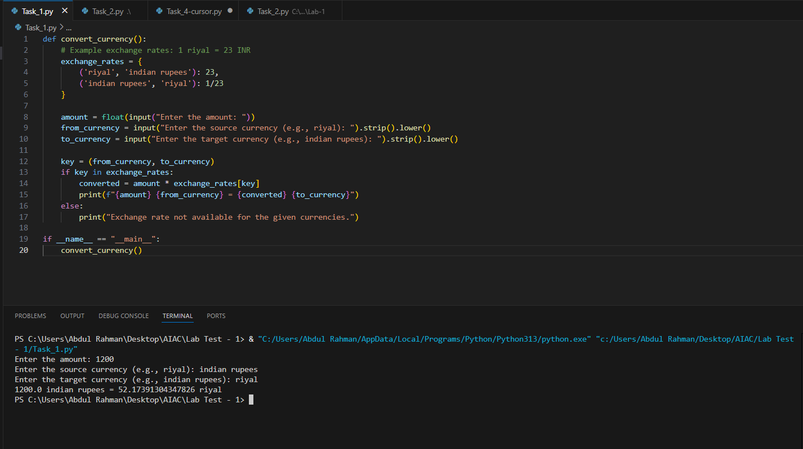

TASK 2:

Write a Python program to extract all email addresses from a block of text using regular  
expressions. GitHub Copilot along with VS Code. Use zero shot prompting

Prompt:

Write a python programme to extract all email addresses from a block of text using regular  
expression and take input from console .

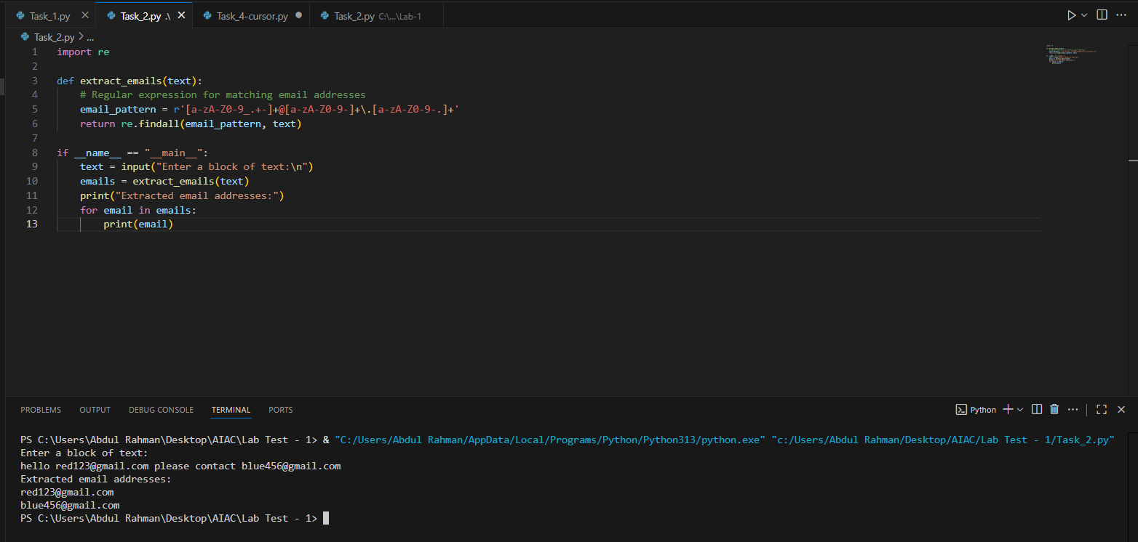

TASK – 3:

Given a list of movies with their genres, Write a Python function that recommends movies  
based on a user’s preferred genre. Use the Cursor AI tool. Use few shot prompting.

Prompt: Write a python programme which recommends movie to user on the based on genre in the given list of movies with genres with want user wants .

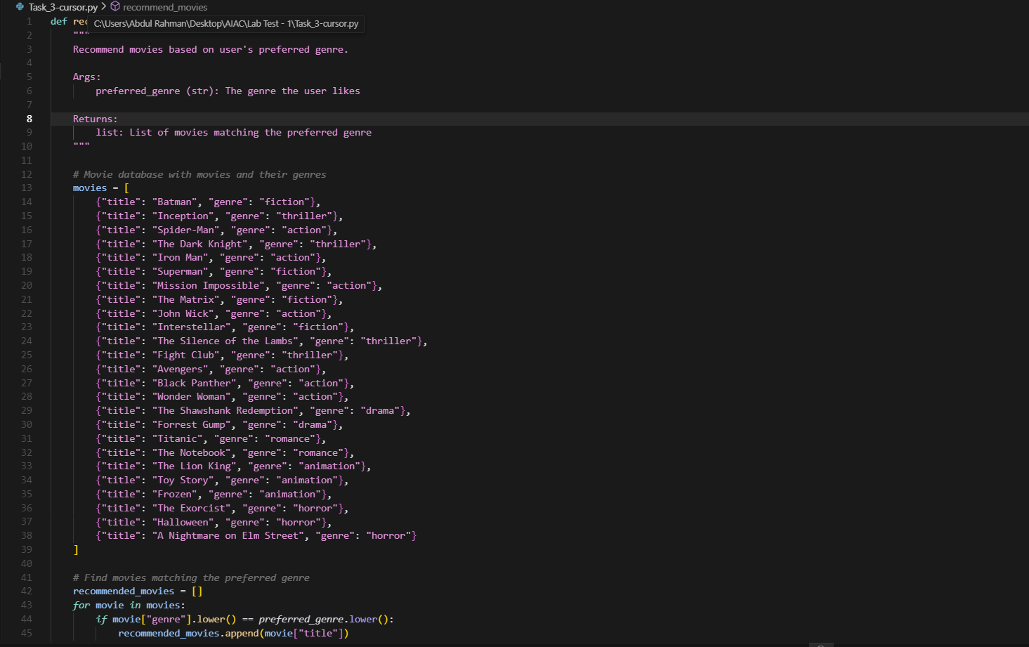

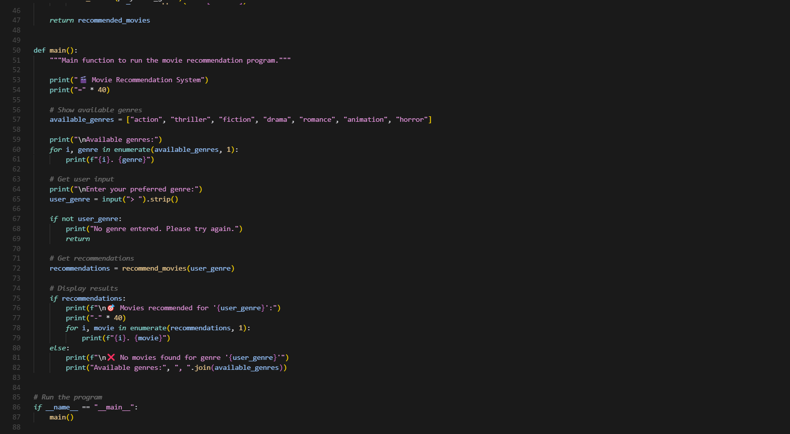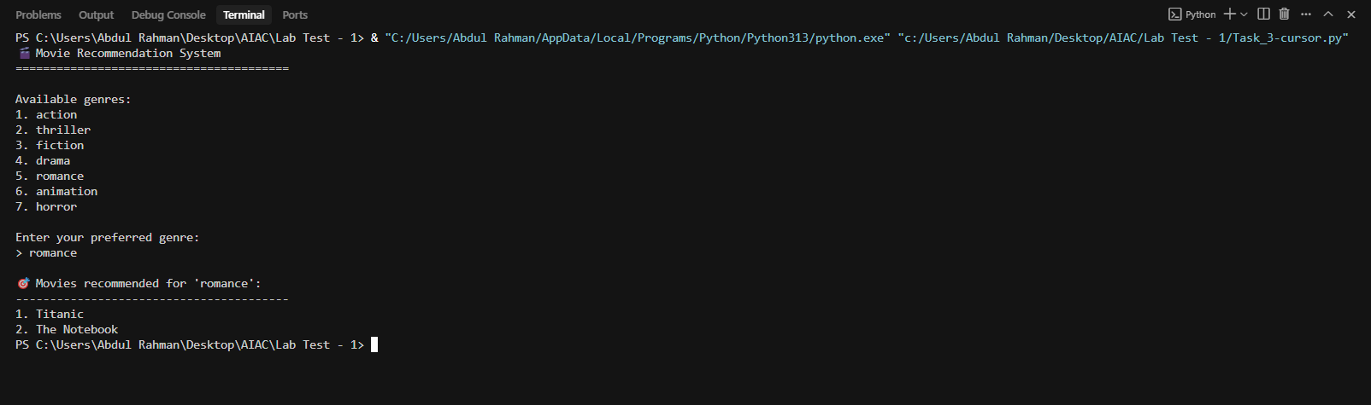

TASK -4:

Write Python code that reads a CSV file containing student names and marks in 3 subjects.  
Calculate the total and average marks for each student. Use the Cursor AI tool.

Prompt: Write a Python programme that reads a CSV file containing student names and marks in 3 subjects.  
Calculate the total and average marks for each student

i